Name: Ken Lin

SID: 006198682

Github repository of my code : <https://github.com/DehNutCase/CSE-461/tree/master/lab3>

I believe all parts are completed successfully.

However, I don’t know how many points they are worth (the lab 3 page doesn’t say), so I assumed 20 points.

20 Points

**Report:**

Part I, Basics:

Create Hello World in Android emulator.

Screenshot:

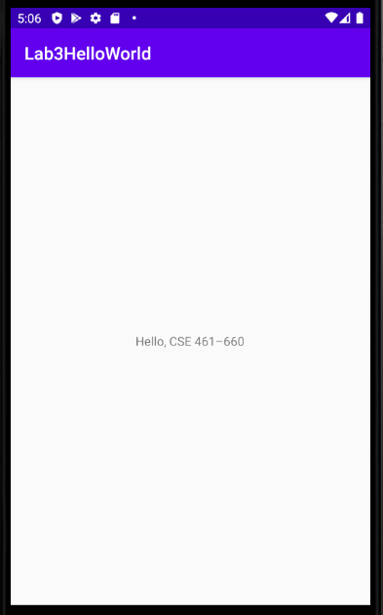

Code:

activity_main.xml

|  |
| --- |
| *<?***xml version="1.0" encoding="utf-8"***?> <!--most of code taken from https://www.tutorialspoint.com/android/android_hello_world_example.htm-->* <**RelativeLayout xmlns:android="http://schemas.android.com/apk/res/android"  xmlns:tools="http://schemas.android.com/tools"  android:layout_width="match_parent"  android:layout_height="match_parent"** >   <**TextView  android:layout_width="wrap_content"  android:layout_height="wrap_content"  android:layout_centerHorizontal="true"  android:layout_centerVertical="true"  android:text="@string/hello_world"  tools:context=".MainActivity"** />  </**RelativeLayout**> |

strings.xml

|  |
| --- |
| <**resources**>  *<!--most of code taken from https://www.tutorialspoint.com/android/android_hello_world_example.htm-->* <**string name="app_name"**>Lab3HelloWorld</**string**>  <**string name="hello_world"**>"Hello, CSE 461–660"</**string**>  <**string name="menu_settings"**>Settings</**string**>  <**string name="title_activity_main"**>MainActivity</**string**> </**resources**> |

MainActivity.java

|  |
| --- |
| **package** com.example.lab3helloworld;  **import** androidx.appcompat.app.AppCompatActivity;  **import** android.os.Bundle;  **public class** MainActivity **extends** AppCompatActivity {   @Override  **protected void** onCreate(Bundle savedInstanceState) {  **super**.onCreate(savedInstanceState);  setContentView(R.layout.activity_main);  } } |

Part II, Simple Calculator:

Create Simple Calculator and replace buttons of operators with images.

Screenshot:

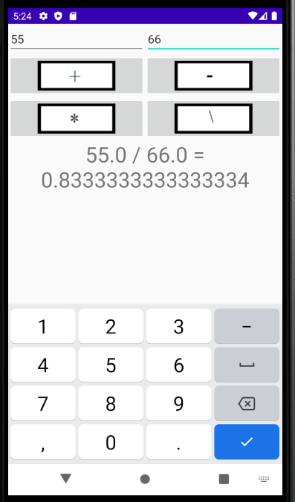

Code:

Activity_main.xml

|  |
| --- |
| *<?***xml version="1.0" encoding="utf-8"***?>* <**LinearLayout  xmlns:android="http://schemas.android.com/apk/res/android"  android:orientation="vertical"  android:layout_width="fill_parent"  android:layout_height="fill_parent"**>  <**LinearLayout  android:layout_width="match_parent"  android:layout_height="wrap_content"  android:id="@+id/linearLayout1"  android:layout_marginLeft="12pt"  android:layout_marginRight="12pt"  android:layout_marginTop="4pt"**>  <**EditText  android:layout_weight="1"  android:layout_height="wrap_content"  android:layout_marginRight="6pt"  android:id="@+id/t1"  android:layout_width="match_parent"  android:inputType="numberDecimal"**>  </**EditText**>  <**EditText  android:layout_height="wrap_content"  android:layout_weight="1"  android:layout_marginLeft="6pt"  android:id="@+id/t2"  android:layout_width="match_parent"  android:inputType="numberDecimal"**>  </**EditText**>  </**LinearLayout**>  <**LinearLayout  android:layout_width="match_parent"  android:layout_height="wrap_content"  android:id="@+id/linearLayout2"  android:layout_marginTop="4pt"  android:layout_marginLeft="6pt"  android:layout_marginRight="6pt"**>  <**ImageButton  android:layout_height="wrap_content"  android:layout_width="match_parent"  android:layout_weight="1"  android:src="@drawable/plus_button"  android:id="@+id/plus"**>  </**ImageButton**>  <**ImageButton  android:layout_height="wrap_content"  android:layout_width="match_parent"  android:layout_weight="1"  android:src="@drawable/minux_button"  android:id="@+id/minus"**>  </**ImageButton**>  </**LinearLayout**>   <**LinearLayout  android:layout_width="match_parent"  android:layout_height="wrap_content"  android:id="@+id/linearLayout3"  android:layout_marginTop="4pt"  android:layout_marginLeft="6pt"  android:layout_marginRight="6pt"**>   <**ImageButton  android:layout_height="wrap_content"  android:layout_width="match_parent"  android:layout_weight="1"  android:src="@drawable/multiply_button"  android:id="@+id/multiply"**>  </**ImageButton**>  <**ImageButton  android:layout_height="wrap_content"  android:layout_width="match_parent"  android:layout_weight="1"  android:src="@drawable/divide_button"  android:id="@+id/divide"**>  </**ImageButton**>  </**LinearLayout**>   <**TextView  android:id="@+id/displayResult"  android:layout_width="match_parent"  android:layout_height="wrap_content"  android:layout_centerHorizontal="true"  android:layout_centerVertical="true"  android:gravity="center_horizontal"  android:textSize="32dp"**>  </**TextView**> </**LinearLayout**> |

MainActivity.java

|  |
| --- |
| **package** com.example.lab3simplecalculator;  **import** androidx.appcompat.app.AppCompatActivity; *//import android.support.v7.app.AppCompatActivity;* **import** android.os.Bundle; **import** android.app.Activity; **import** android.content.DialogInterface; **import** android.content.DialogInterface.OnClickListener; **import** android.text.TextUtils; **import** android.view.Menu; **import** android.view.View; **import** android.widget.Button; **import** android.widget.ImageButton; **import** android.widget.EditText; **import** android.widget.TextView;  **public class** MainActivity **extends** Activity **implements** View.OnClickListener{  EditText t1;  EditText t2;   ImageButton plus;  ImageButton minus;  ImageButton multiply;  ImageButton divide;   TextView displayResult;   String oper = **""**;   */** Called when the activity is first created. */* @Override  **public void** onCreate(Bundle savedInstanceState) {  **super**.onCreate(savedInstanceState);  setContentView(R.layout.activity_main);   *// find the EditText elements (defined in res/layout/activity_main.xml* t1 = (EditText) findViewById(R.id.t1);  t2 = (EditText) findViewById(R.id.t2);   plus = (ImageButton) findViewById(R.id.plus);  minus = (ImageButton) findViewById(R.id.minus);  multiply = (ImageButton) findViewById(R.id.multiply);  divide = (ImageButton) findViewById(R.id.divide);   displayResult = (TextView) findViewById(R.id.displayResult);   *// set listeners* plus.setOnClickListener( **this** );  minus.setOnClickListener( **this**);  multiply.setOnClickListener( **this**);  divide.setOnClickListener( **this**);  }   *// @Override* **public void** onClick( View view ) {  **double** num1 = 0;  **double** num2 = 0;  **double** result = 0;   *// check if the fields are empty* **if** (TextUtils.isEmpty(t1.getText().toString())  || TextUtils.isEmpty(t2.getText().toString())) {  **return**;  }   *// read EditText and fill variables with numbers* num1 = Float.parseFloat(t1.getText().toString());  num2 = Float.parseFloat(t2.getText().toString());   *// perform operations  // save operator in oper for later use* **switch** ( view.getId() ) {  **case** R.id.plus:  oper = **"+"**;  result = num1 + num2;  **break**;  **case** R.id.minus:  oper = **"-"**;  result = num1 - num2;  **break**;  **case** R.id.multiply:  oper = **"*"**;  result = num1 * num2;  **break**;  **case** R.id.divide:  oper = **"/"**;  result = num1 / num2;  **break**;  **default**:  **break**;  }   *// form the output line* displayResult.setText(num1 + **" "** + oper + **" "** + num2 + **" = "** + result);  } } |

Part III, Android Fragments:

Simple application with 2 fragments, Fragment A and Fragment B. When the user clicks on a button, it presents Fragment A with a yellow background. When the user clicks on the other button, present Fragment B with a blue background.

(Colors aren’t the same as in the example.)

Screenshot:

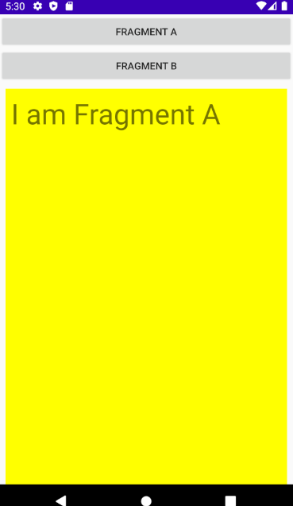 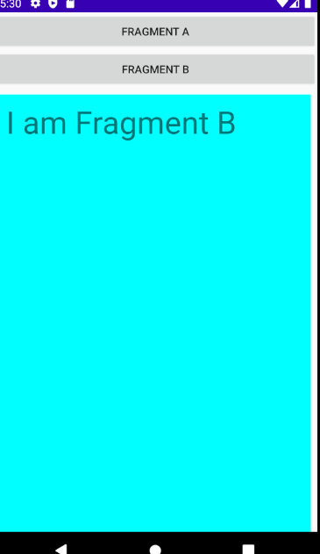

Code:

Activity_main.xml

|  |
| --- |
| *<?***xml version="1.0" encoding="utf-8"***?>* <**LinearLayout  xmlns:android="http://schemas.android.com/apk/res/android"  xmlns:app="http://schemas.android.com/apk/res-auto"  xmlns:tools="http://schemas.android.com/tools"  android:id="@+id/container"  android:layout_width="match_parent"  android:layout_height="match_parent"  android:orientation="vertical"**>   <**Button  android:id="@+id/button_a"  android:layout_width="match_parent"  android:layout_height="wrap_content"  android:text="@string/fragment_a"  android:onClick="fragA"  app:layout_constraintTop_toTopOf="parent"**/>   <**Button  android:id="@+id/button_b"  android:layout_width="match_parent"  android:layout_height="wrap_content"  android:layout_marginStart="0dp"  android:layout_marginEnd="0dp"  android:text="@string/fragment_b"  app:layout_constraintTop_toBottomOf="@id/button_a"**/>   <**FrameLayout  android:layout_width="match_parent"  android:layout_height="fill_parent"  app:layout_constraintLeft_toLeftOf="parent"  app:layout_constraintRight_toRightOf="parent"  app:layout_constraintTop_toBottomOf="@id/button_b"  android:layout_marginStart="8dp"  android:layout_marginTop="8dp"  android:layout_marginEnd="8dp"  android:textSize="40sp"  android:id="@+id/fragment_location"**/>  </**LinearLayout**> |

Fragment_a.xml

|  |
| --- |
| *<?***xml version="1.0" encoding="utf-8"***?>* <**androidx.constraintlayout.widget.ConstraintLayout  xmlns:android="http://schemas.android.com/apk/res/android"  xmlns:app="http://schemas.android.com/apk/res-auto"  xmlns:tools="http://schemas.android.com/tools"  android:layout_width="match_parent"  android:layout_height="fill_parent"  android:background="#FFFF00"  tools:context=".ui.AFragment"**>   <**TextView  android:id="@+id/text_a"  android:layout_width="match_parent"  android:layout_height="wrap_content"  android:layout_marginStart="8dp"  android:layout_marginTop="8dp"  android:layout_marginEnd="8dp"  android:textSize="40sp"  android:text="@string/i_am_fragment_a"  app:layout_constraintEnd_toEndOf="parent"  app:layout_constraintStart_toStartOf="parent"  app:layout_constraintTop_toTopOf="parent"** /> </**androidx.constraintlayout.widget.ConstraintLayout**> |

Fragment_b.xml

|  |
| --- |
| *<?***xml version="1.0" encoding="utf-8"***?>* <**androidx.constraintlayout.widget.ConstraintLayout  xmlns:android="http://schemas.android.com/apk/res/android"  xmlns:app="http://schemas.android.com/apk/res-auto"  xmlns:tools="http://schemas.android.com/tools"  android:layout_width="match_parent"  android:layout_height="fill_parent"  android:background="#00FFFF"  tools:context=".ui.BFragment"** >   <**TextView  android:id="@+id/text_a"  android:layout_width="match_parent"  android:layout_height="wrap_content"  android:layout_marginStart="8dp"  android:layout_marginTop="8dp"  android:layout_marginEnd="8dp"  android:textSize="40sp"  android:text="@string/i_am_fragment_b"  app:layout_constraintEnd_toEndOf="parent"  app:layout_constraintStart_toStartOf="parent"  app:layout_constraintTop_toTopOf="parent"** /> </**androidx.constraintlayout.widget.ConstraintLayout**> |

MainActivity.java

|  |
| --- |
| **package** com.example.androidfragments;  **import** android.app.Fragment; **import** android.os.Bundle; **import** com.example.androidfragments.ui.AFragment; **import** com.example.androidfragments.ui.BFragment; **import** androidx.fragment.app.FragmentActivity; **import** androidx.fragment.app.FragmentManager; **import** androidx.fragment.app.FragmentTransaction; **import** android.view.View; **import** android.widget.Button;   **public class** MainActivity **extends** FragmentActivity {  @Override  **public void** onCreate(Bundle savedInstanceState) {  **super**.onCreate(savedInstanceState);  setContentView(R.layout.***activity_main***);  FragmentTransaction ft = getSupportFragmentManager().beginTransaction();  ft.replace(R.id.***fragment_location***, **new** AFragment());  ft.commit();   Button button = (Button) findViewById(R.id.***button_b***);  button.setOnClickListener(**new** View.OnClickListener() {  **public void** onClick(View v) {  FragmentTransaction ft = getSupportFragmentManager().beginTransaction();  ft.replace(R.id.***fragment_location***, **new** BFragment());  ft.commit();  }  });  }    **public void** fragA (View view) {  FragmentTransaction ft = getSupportFragmentManager().beginTransaction();  ft.replace(R.id.***fragment_location***, **new** AFragment());  ft.commit();  }   } |

AFragment.java

|  |
| --- |
| **package** com.example.androidfragments.ui;  **import** android.os.Bundle; **import** android.view.LayoutInflater; **import** android.view.View; **import** android.view.ViewGroup; **import** com.example.androidfragments.R; **import** androidx.fragment.app.Fragment;  **public class** AFragment **extends** Fragment {  @Override  **public** View onCreateView(LayoutInflater inflater, ViewGroup container,  Bundle savedInstanceState) {  *// Inflate the layout for this fragment* **return** inflater.inflate(R.layout.***fragment_a***, container, **false**);  } } |

BFragment.java

|  |
| --- |
| **package** com.example.androidfragments.ui;  **import** android.os.Bundle; **import** android.view.LayoutInflater; **import** android.view.View; **import** android.view.ViewGroup; **import** com.example.androidfragments.R; **import** androidx.fragment.app.Fragment;  **public class** BFragment **extends** Fragment {  @Override  **public** View onCreateView(LayoutInflater inflater, ViewGroup container,  Bundle savedInstanceState) {  *// Inflate the layout for this fragment* **return** inflater.inflate(R.layout.***fragment_b***, container, **false**);  } } |